**Databases**

**Test (Must implement add, delete, update, read test)**

-testId String

-testName String

-testCost Float

-testDetails String

**Diagnostic Center (Must implement add, delete, update, read diagnostic center)**

-centerId: String

-centerName: String

-centerAddress: String

-listOfTests: String(contains space separated testIds)

-appointmentList: String(contains space separated appointmentIds)

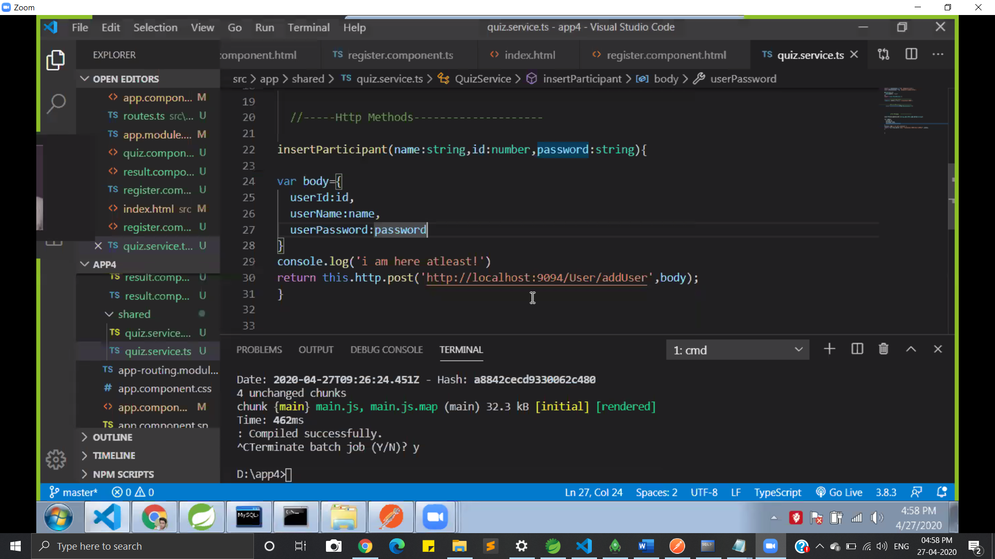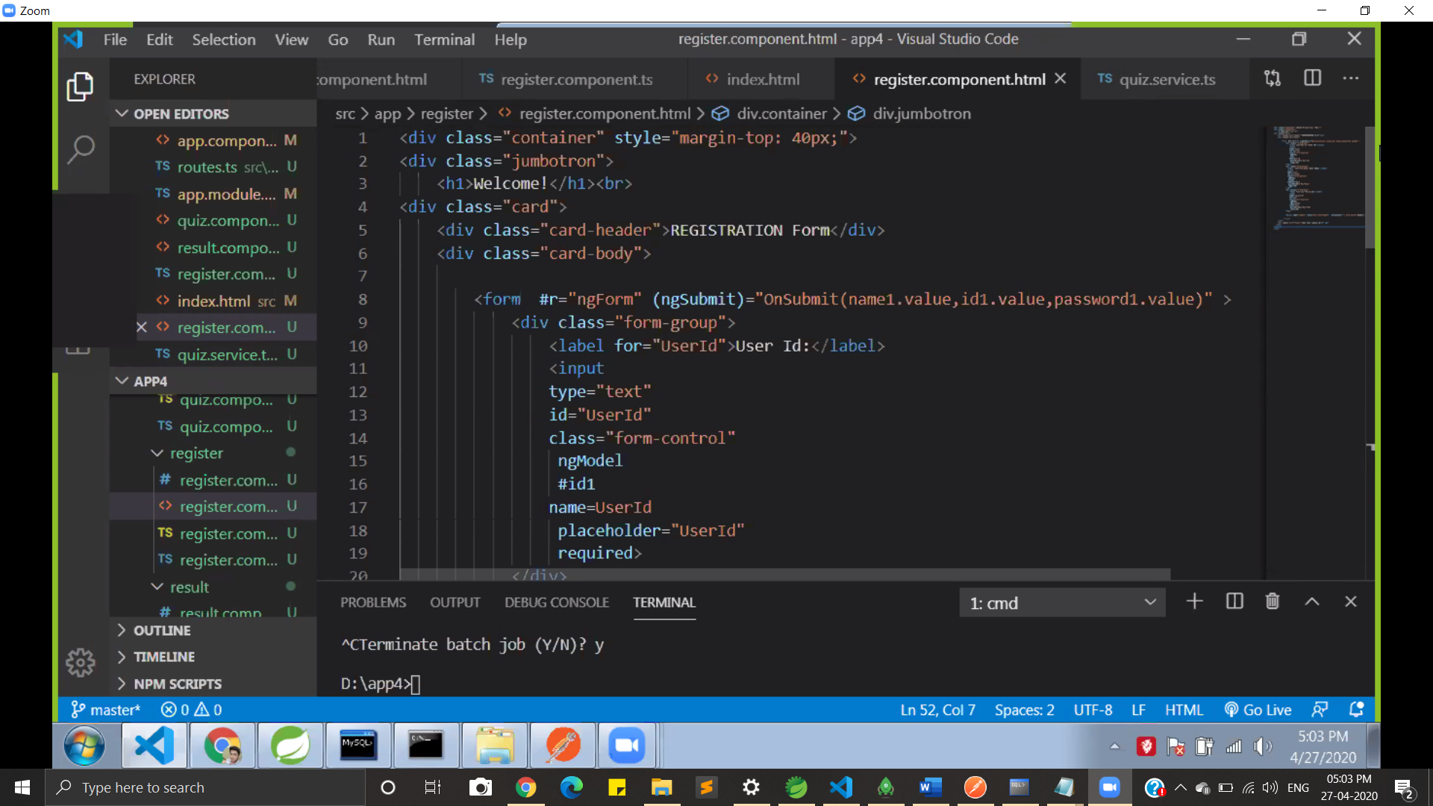

**Appointment(Must implement add, delete, update, read appointment)**

-appointmentId: String

-user User;

-test: Test

-datetime: DateTime

-totalCost: Float

-approved: Boolean

**User(Must implement login, logout, forgot password, register new user)**

-userId: String

-userPassword: String

-userName: String

-contactNo: BigInteger

-emailId: String

-gender: String

-age: Integer

**Test Reports(Must implement add, delete, update, read Test Report)**

-user User;

-appointmentId: String

-testReport: String

Ng g s user🡪creates service for user